**Business Problem**

In recent year, City Hotel and Resort Hotel have seen high cancellation rates. Each hotel is now dealing with a number of issues as a result, include fewer revenues and less than idea hotel room use. Consequently,lowering cancellation rates is both hotels’primary goal in order to increase their efficiency in generating revenue, and for us to offer thorough business advice to address this problem.

The analysis of hotel booking cancellation as well as other factor that have no bearing on their business and yearly revenue generation are the main topics of this report.

**Assumptions**

1. No unusual occurrences between 2015 and 2017 will have substantial impact on the data used.
2. The information is still current and can be used to analyze a hotel’s possible plans in an efficient manner.
3. There are no unanticipated negatives to the hotel employing any advised technique.
4. The hotels are not currently using any of the suggested solutions.
5. The biggest factor affecting the effectiveness of earning income is booking cancellations.
6. Cancellations result in vacant rooms of the booked length of time.
7. Client make hotel reservation the same year they make cancellations.

**Research Question**

1. What are the variables that affect hotel reservation cancellation?
2. How can we make hotel reservation cancellation better?
3. How will hotels be assisted in making pricing and promotional decisions?

**Hypothesis**

1. More cancellations occur when prices are higher.
2. When there is longer waiting list, customer tend cancel more frequently
3. The majority of client are coming from offline travel agent to make their reservation?

**Analysis and Findings**

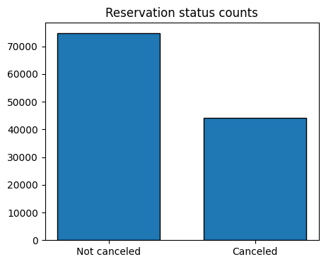

The accompanying bar graph show the percentage of reservation that are cancelled and those that are not. It is obvious that there are still a significant number of reservation that have not been cancelled. There are still 37% of client who cancelled their reservation, which has a significant impact on the hotels’earnings

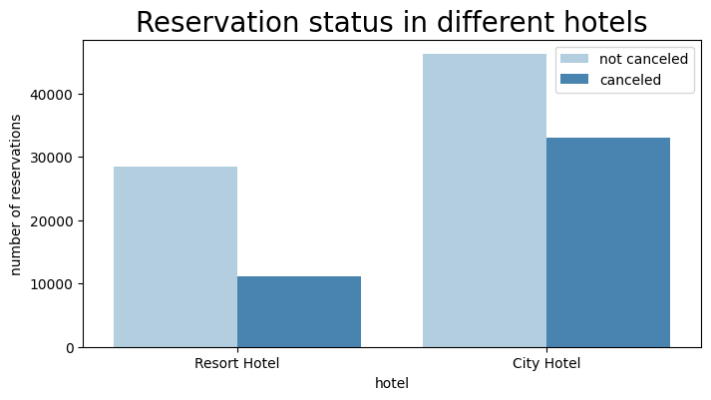

In comparison to resort hotels, city hotels have more booking. It’s possible that resort hotels are more expensive than those in cities.

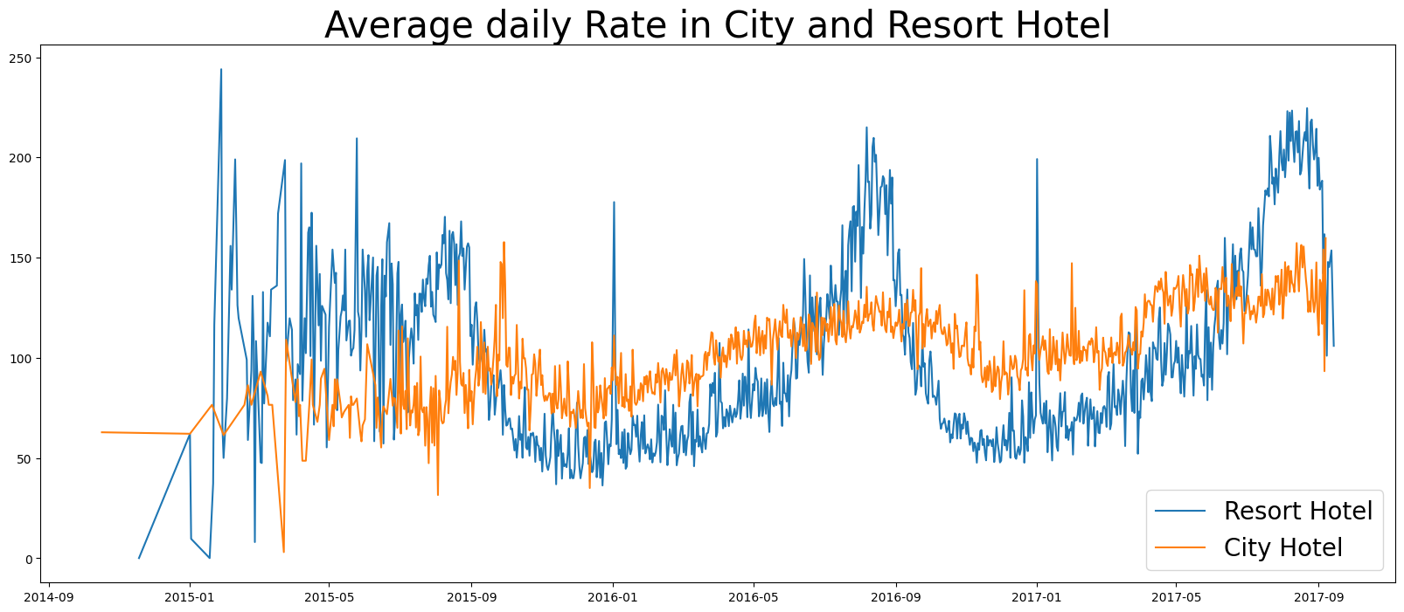

The line graph above show that, on certain days, the average daily rate for a city hotel is less than that of resort hotel, and on other day, its is even less. It goes without saying that weekends and holidays may see a rise in resort hotel rates.

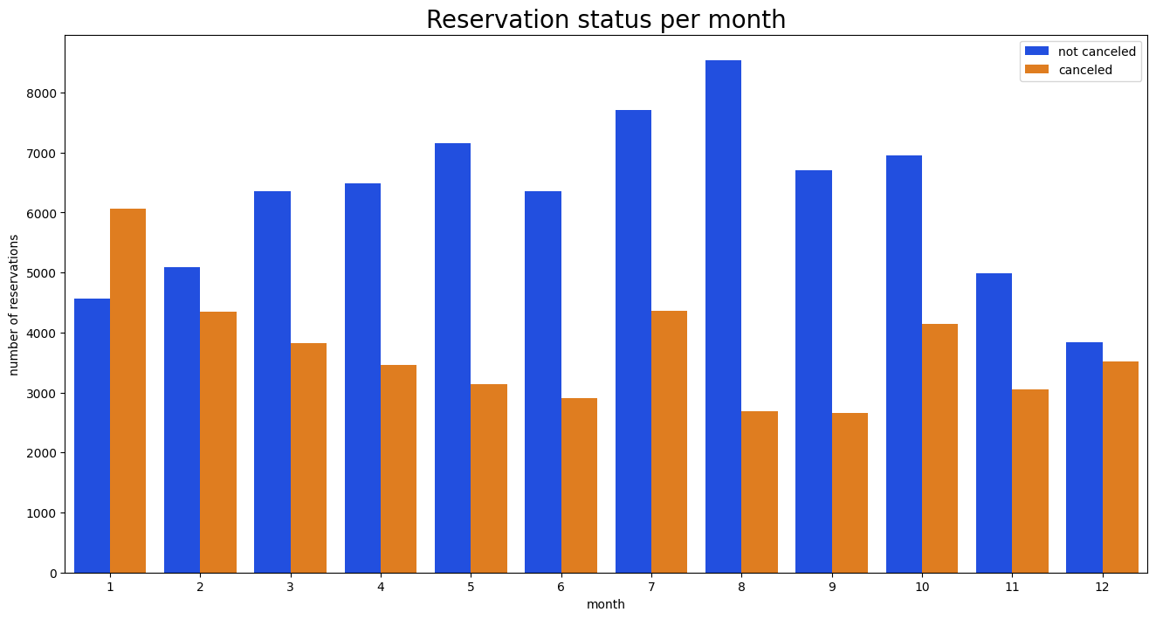

We have developed the grouped bar graph to analyze the months with the highest and lowest reservations levels according to reservation status. As can be seen, both the number of confirmed reservation and the number of cancelled reservation are largest in the month of August. Whereas January Is the month with the most cancelled reservations.

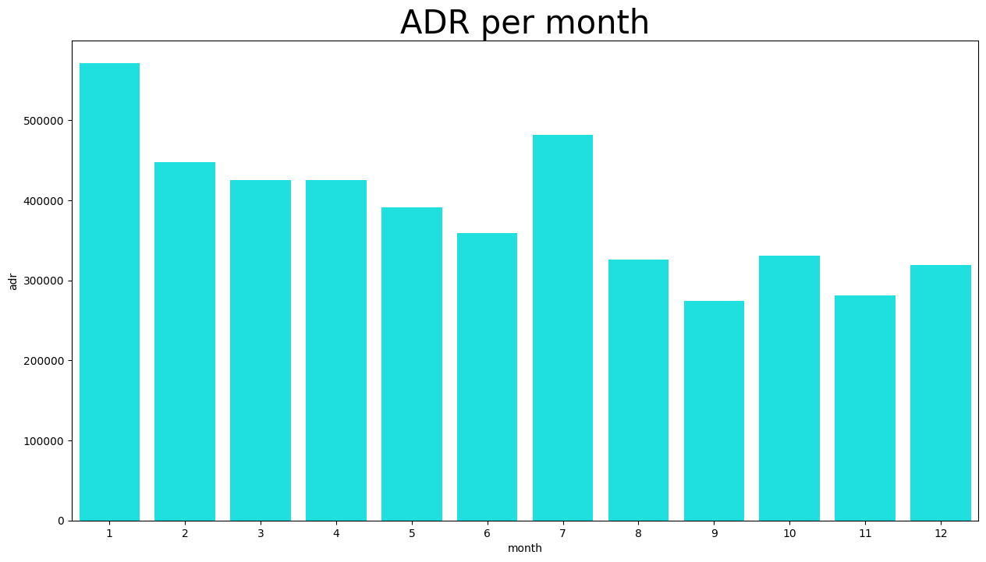

These bar graph demonstrates that cancellation are most common when price are greatest and are least common when they are lowest. Therefor, the cost of the accommodation is solely responsible for the cancellation.

Now, let’s see which country has the highest reservation cancelled. The top country is Portugal with the highest number of cancellations.

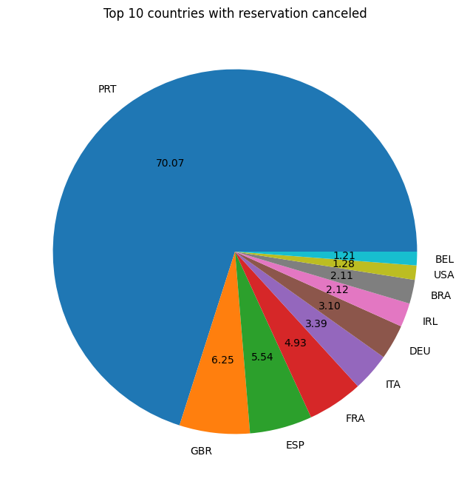

Let’s check the area from where guests are visits the hotels and making reservations. Is it coming from direct or groups, online or offline travel agents? Around 46% of the client come from travel agencies, whereas 27% come from groups. Only 4% of clients book hotel directly by visiting them and making reservations.

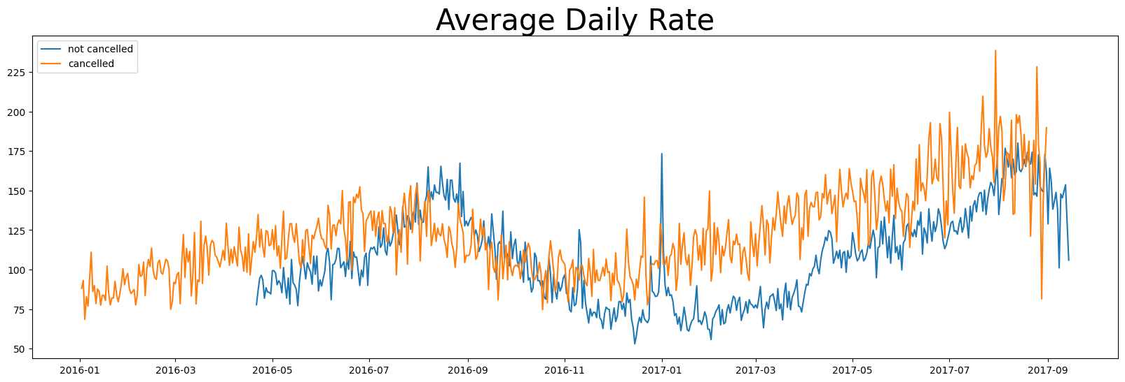

As seen in the graph, reservations are cancelled when the average daily rate is higher than when it is not cancelled. It clearly proves all the above analysis, that the higher price leads to higher cancellation.

**Suggestions**

1. Cancellation rates rise as the price does. In order to prevent cancellations of reservations, hotels could work on their pricing strategies and try to lower the rates for specific hotel based on location. They can also provide some discounts to the consumers.
2. As the ratio of the cancellation and not cancellation of the resort hotel is higher in the resort hotel than city hotels. So the hotels should provide a reasonable discount on the room prices on the weekend or no holidays.
3. In the month of January, hotels can start campaigns or marketing with a reasonable amount to increase their revenue as the cancellation is the highest in the month.
4. They can also increase the quality of their hotels and their services mainly in Portugal to reduce the cancellation rate.